9999X399X9XL

Leaving Certificate Examination 2021 Answerbook for use in the subjects listed in the table below only.
Scrúdú Ardteistiméireachta 2021 Leabhar freagraí le húsáid sna hábhair atá liostaithe sa tábla thíos amháin.

Students Name
School
Teacher

Shade in fully the circle for the subject, the level, and the language (English or Irish) that you are answering through.
Subject
Ábhar
Accounting  Cuntasaíocht | English Paper 1
Applied Mathematics  Matamaitic Fheidhmeach | English Paper 2
Art  Ealaín | History  Stair
Chemistry  Ceimic | Physics  Fisic
Engineering  Innealtóireacht | Religious Education  Oideachas Reiligiúnach

Level
Leibhéal
Higher
Ardleibhéal
Ordinary
Gnáthleibhéal

Scáthaigh an ciorcal go hiomlán le haghaidh an ábhair, an leibhéil, agus na teanga (Béarla nó Gaeilge) trína bhfreagróidh tú.

Examination Number
Answered through
Freagraíodh trí
English
Gaeilge

Scrúduimhir

Day and Month of Birth
Dáta agus Mí do Bhreithe
For example, 3rd February is 0302
Mar shampla, 0302 is ea 3 Feabhra

Make and model of calculator used
Déanamh agus múnla an áireamháin a úsáideadh

Instructions
- Write your answers in blue or black pen. You may use pencil for graphs and diagrams only.

- Write all answers into the spaces provided in this answerbook. This answerbook will be scanned and your work will be presented to an examiner on screen. Anything that you write outside of the answer areas may not be seen by the examiner.

- Start each question on a new page. Write the question number in the box at the top of each page. Use the left-hand column to label each part, as shown below. You do not need to use all of the pages in this answerbook. If you run out of space in this answerbook, you may ask the superintendent for more paper.

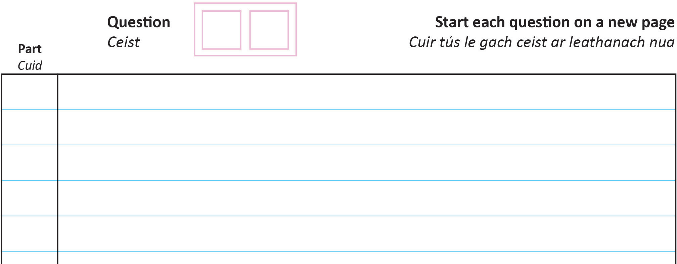

(a) (b)(i)
(b)(ii)
0 4

Treoracha
- Scríobh do chuid freagraí le peann gorm nó dubh. Ní ceadmhach duit peann luaidhe a úsáid ach amháin le haghaidh graf agus léaráidí.

- Scríobh na freagraí go léir sna spásanna atá ann dóibh sa fhreagarleabhar seo. Déanfar an freagarleabhar seo a scanadh agus is ar scáileán a chuirfear do chuid oibre i láthair an
scrúdaitheora. Tá an baol ann nach bhfeicfidh an scrúdaitheoir aon ní a scríobhfaidh tú taobh amuigh de spásanna na bhfreagraí.

- Cuir tús le gach ceist ar leathanach nua. Scríobh uimhir na ceiste sa bhosca ar bharr gach leathanaigh. Úsáid an colún ar thaobh na láimhe clé chun gach cuid a lipéadú, mar a thaispeántar thuas. Ní gá duit gach leathanach sa fhreagarleabhar seo a úsáid. Mura bhfuil dóthain spáis agat sa fhreagarleabhar féadfaidh tú páipéar breise a iarraidh ar an bhfeitheoir.

Part
Cuid
Question
Ceist
Start each question on a new page
Cuir tús le gach ceist ar leathanach nua

Part
Cuid
Question
Ceist
Start each question on a new page
Cuir tús le gach ceist ar leathanach nua

Part
Cuid
Question
Ceist
Start each question on a new page
Cuir tús le gach ceist ar leathanach nua

Part
Cuid
Question
Ceist
Start each question on a new page
Cuir tús le gach ceist ar leathanach nua

Part
Cuid
Question
Ceist
Start each question on a new page
Cuir tús le gach ceist ar leathanach nua

Part
Cuid
Question
Ceist
Start each question on a new page
Cuir tús le gach ceist ar leathanach nua

Part
Cuid
Question
Ceist
Start each question on a new page
Cuir tús le gach ceist ar leathanach nua

Part
Cuid
Question
Ceist
Start each question on a new page
Cuir tús le gach ceist ar leathanach nua

Part
Cuid
Question
Ceist
Start each question on a new page
Cuir tús le gach ceist ar leathanach nua

Part
Cuid
Question
Ceist
Start each question on a new page
Cuir tús le gach ceist ar leathanach nua

Part
Cuid
Question
Ceist
Start each question on a new page
Cuir tús le gach ceist ar leathanach nua

Part
Cuid
Question
Ceist
Start each question on a new page
Cuir tús le gach ceist ar leathanach nua

Part
Cuid
Question
Ceist
Start each question on a new page
Cuir tús le gach ceist ar leathanach nua

Part
Cuid
Question
Ceist
Start each question on a new page
Cuir tús le gach ceist ar leathanach nua

Part
Cuid
Question
Ceist
Start each question on a new page
Cuir tús le gach ceist ar leathanach nua

Part
Cuid
Question
Ceist
Start each question on a new page
Cuir tús le gach ceist ar leathanach nua

Part
Cuid
Question
Ceist
Start each question on a new page
Cuir tús le gach ceist ar leathanach nua

Part
Cuid
Question
Ceist
Start each question on a new page
Cuir tús le gach ceist ar leathanach nua

Part
Cuid
Question
Ceist
Start each question on a new page
Cuir tús le gach ceist ar leathanach nua

Part
Cuid
Question
Ceist
Start each question on a new page
Cuir tús le gach ceist ar leathanach nua

Part
Cuid
Question
Ceist
Start each question on a new page
Cuir tús le gach ceist ar leathanach nua

Part
Cuid
Question
Ceist
Start each question on a new page
Cuir tús le gach ceist ar leathanach nua

Part
Cuid
Question
Ceist
Start each question on a new page
Cuir tús le gach ceist ar leathanach nua

Part
Cuid
Question
Ceist
Start each question on a new page
Cuir tús le gach ceist ar leathanach nua

Part
Cuid
Question
Ceist
Start each question on a new page
Cuir tús le gach ceist ar leathanach nua

Part
Cuid
Question
Ceist
Start each question on a new page
Cuir tús le gach ceist ar leathanach nua

Part
Cuid
Question
Ceist
Start each question on a new page
Cuir tús le gach ceist ar leathanach nua

Part
Cuid
Question
Ceist
Start each question on a new page
Cuir tús le gach ceist ar leathanach nua

Part
Cuid
Question
Ceist
Start each question on a new page
Cuir tús le gach ceist ar leathanach nua

Part
Cuid
Question
Ceist
Start each question on a new page
Cuir tús le gach ceist ar leathanach nua

Part
Cuid
Question
Ceist
Start each question on a new page
Cuir tús le gach ceist ar leathanach nua

Part
Cuid
Question
Ceist
Start each question on a new page
Cuir tús le gach ceist ar leathanach nua

Part
Cuid
Question
Ceist
Start each question on a new page
Cuir tús le gach ceist ar leathanach nua

Part
Cuid
Question
Ceist
Start each question on a new page
Cuir tús le gach ceist ar leathanach nua

